# Mobil Programlama 2 Vize

# Ali Baran

# 1915010061

## Ekran Görüntüleri

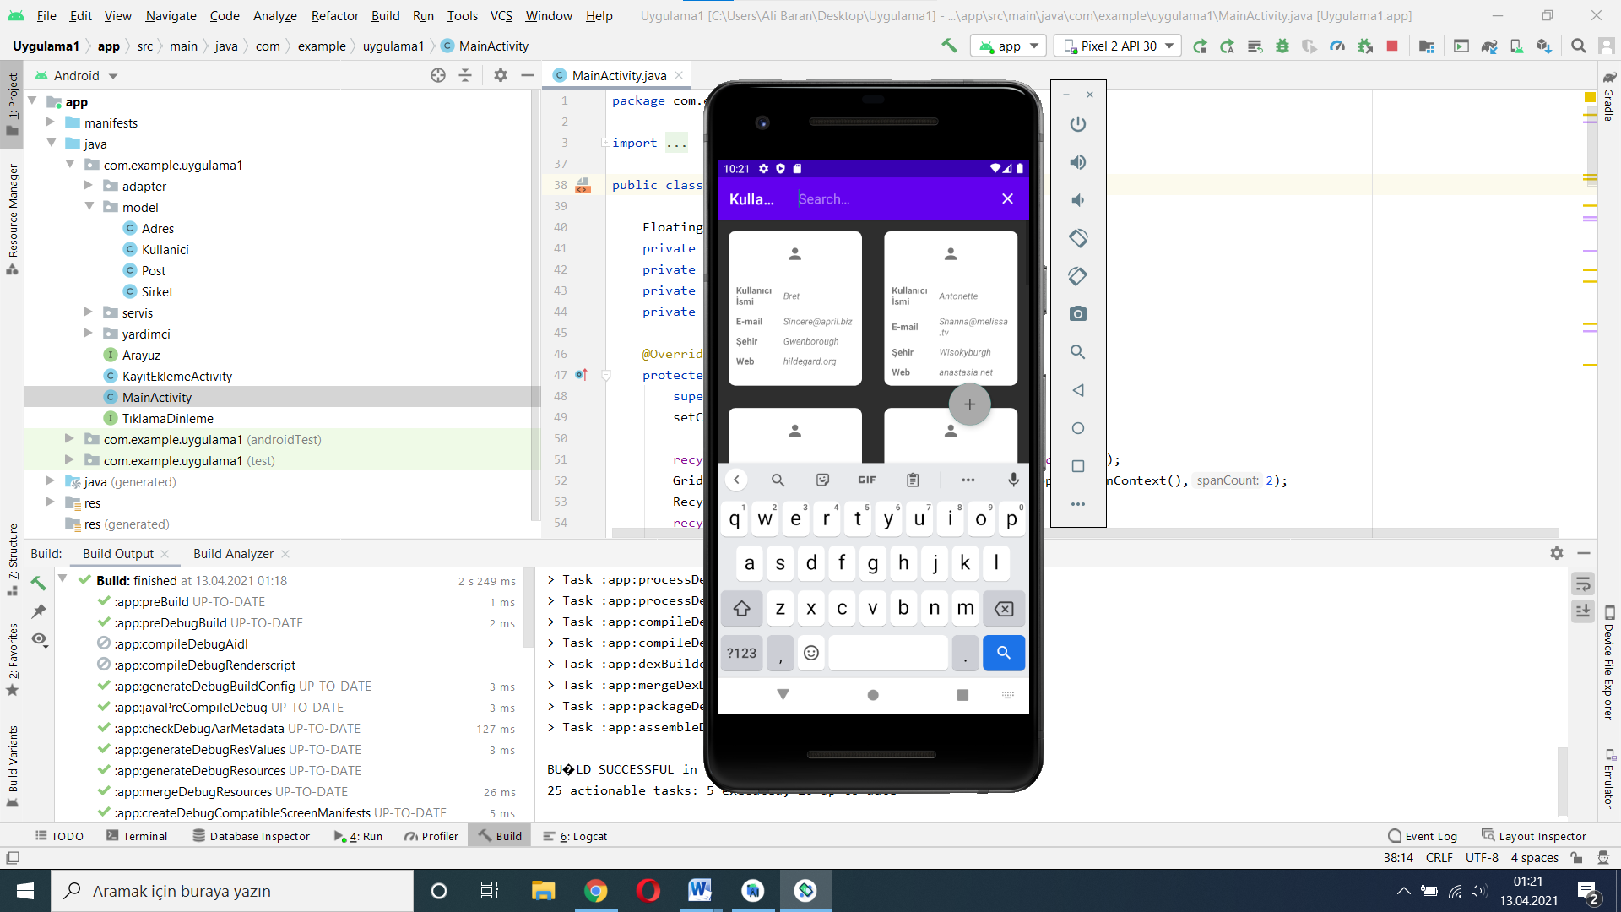

**Şekil 1. Çalışan Ekran Görüntüsü Formatı**

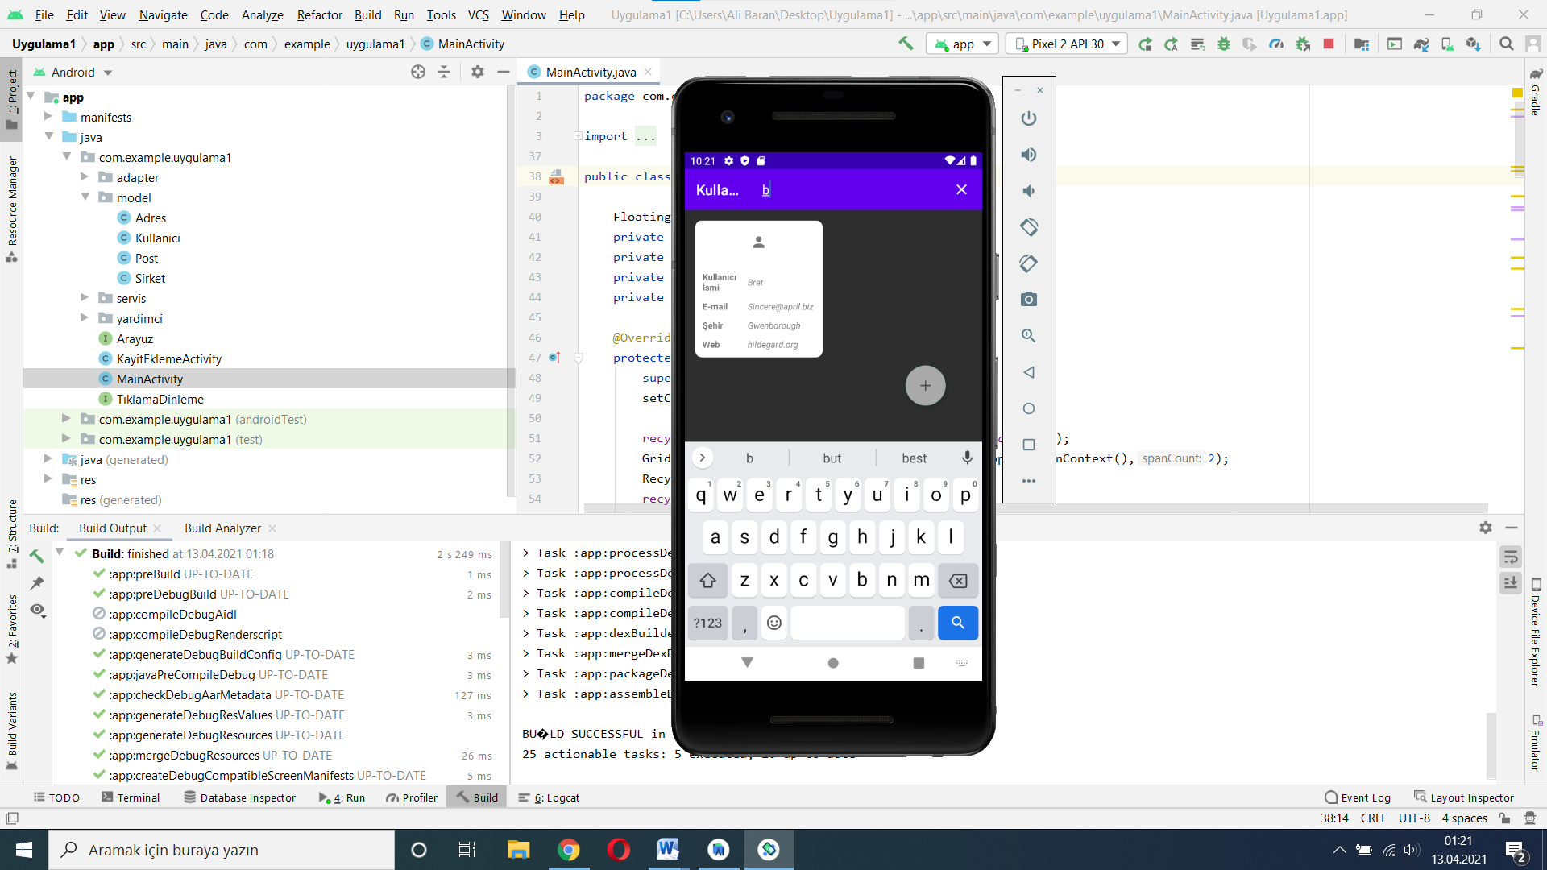

**Şekil 2.Arama Ekranı**

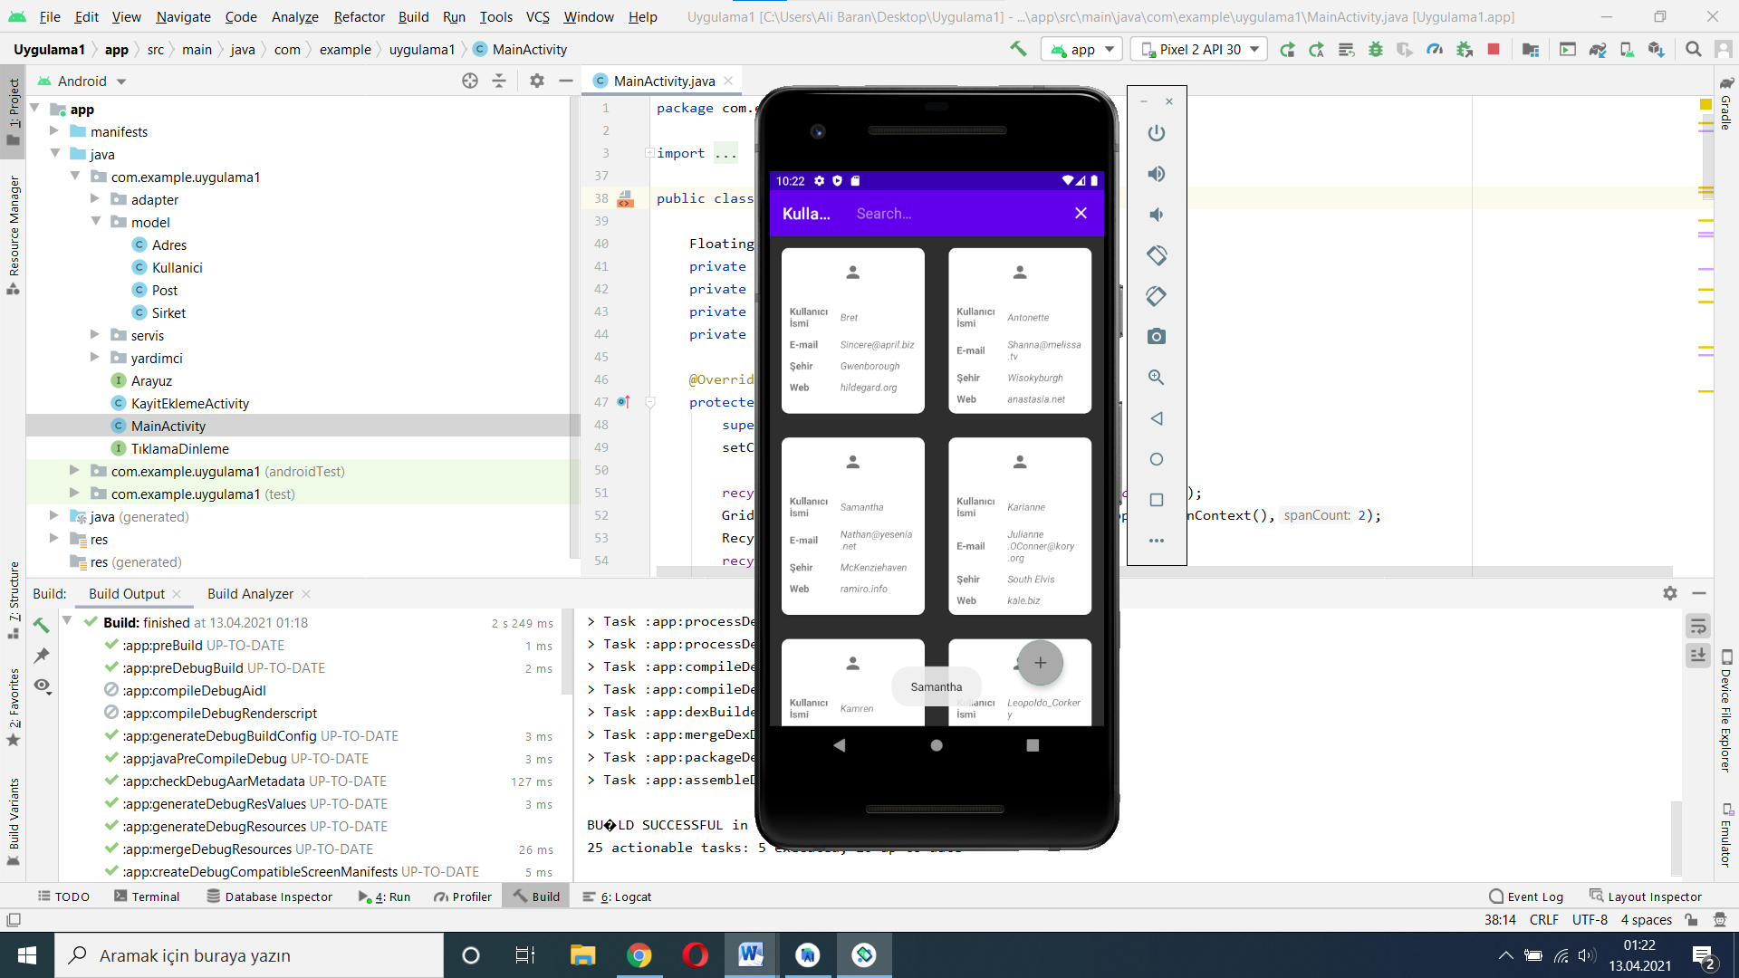

**Şekil 3.Kişiye Basıldığında**

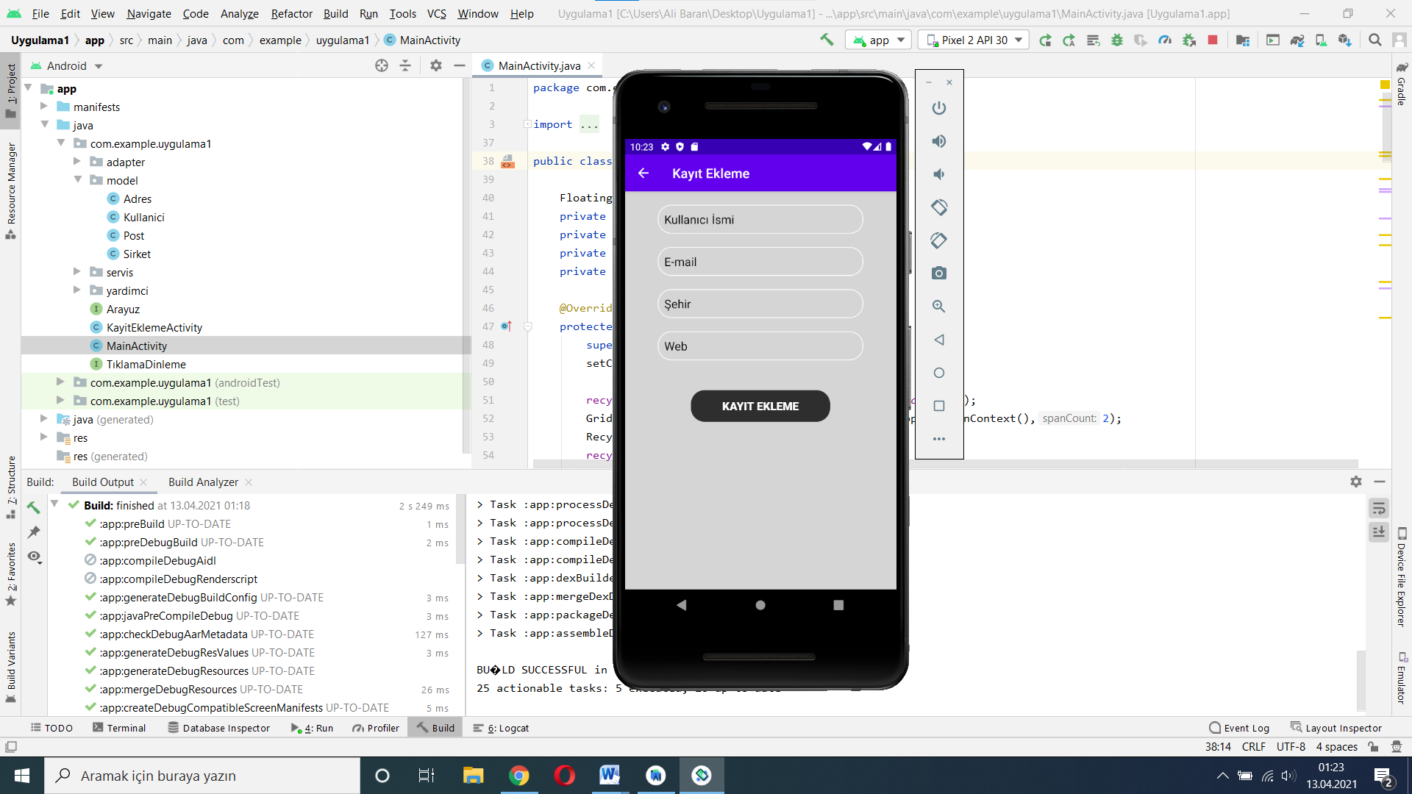

**Şekil 4.Ekleme Ekranı**

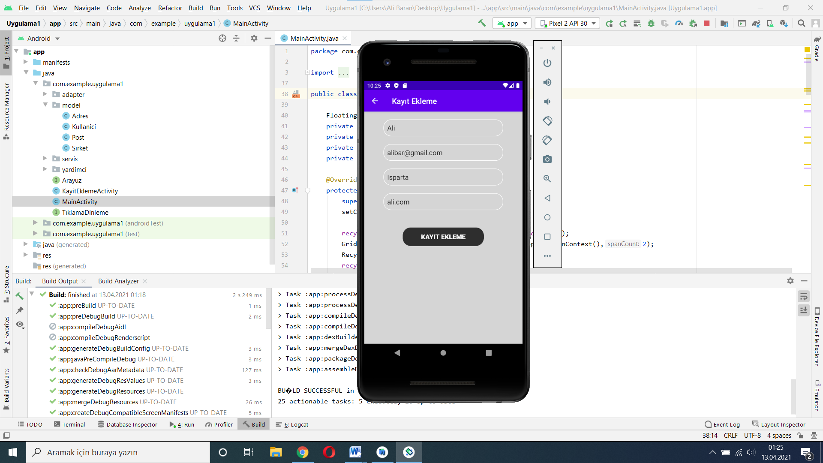

**Şekil 5.Ekleme Öncesi Ekranı**

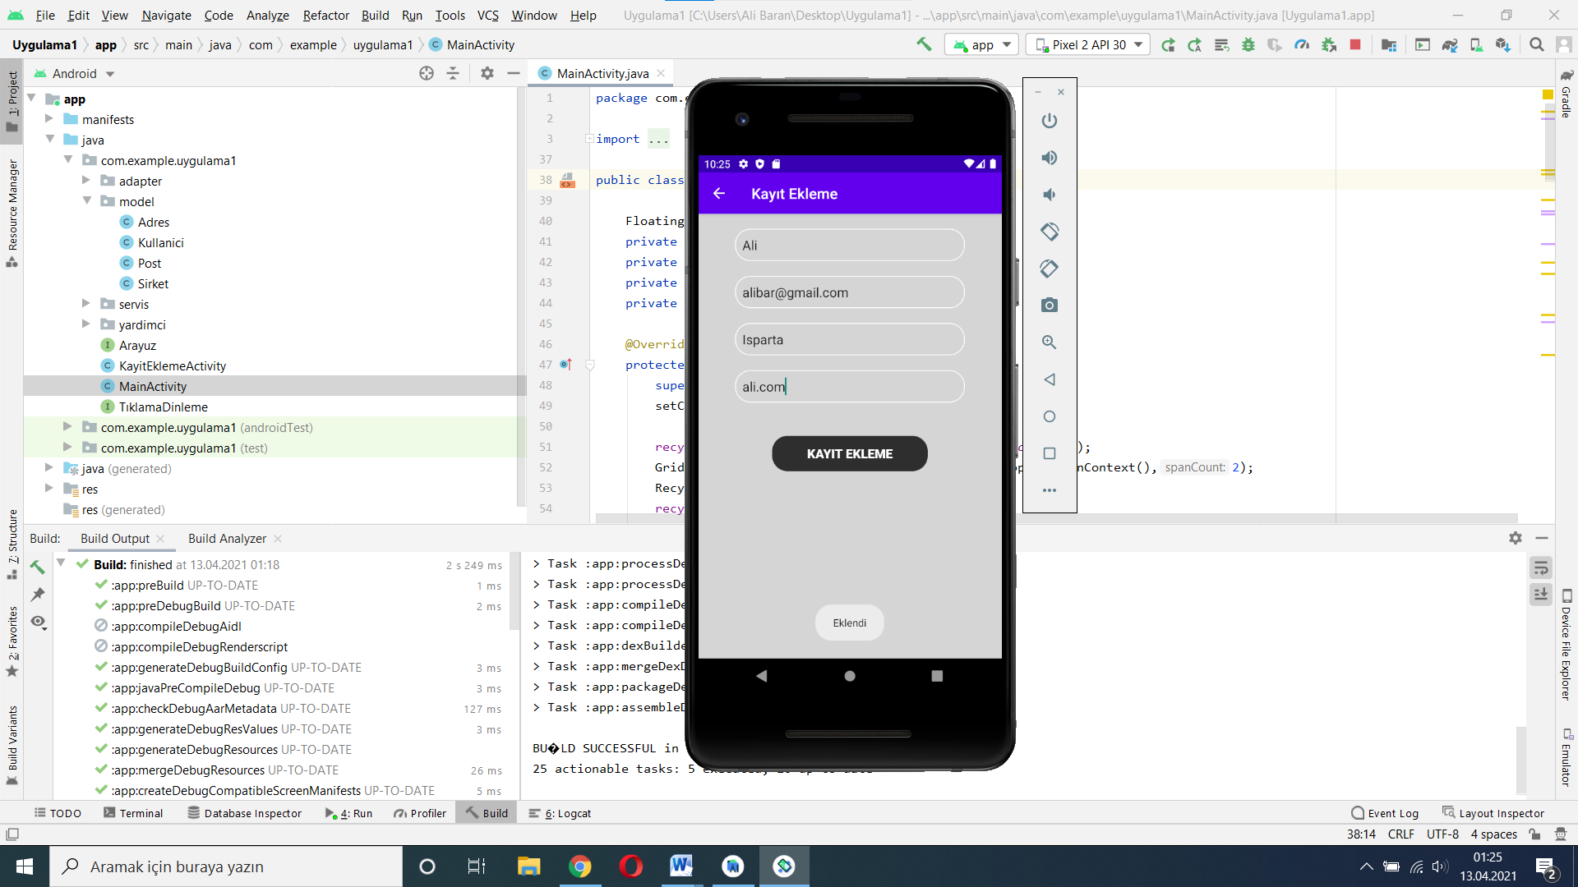

**Şekil 6.Ekleme Sırası Ekranı**

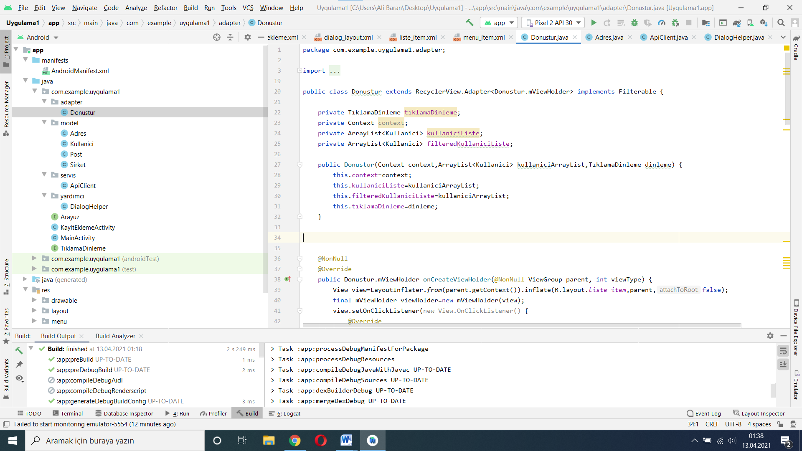

**Şekil 7.Donustur.java**

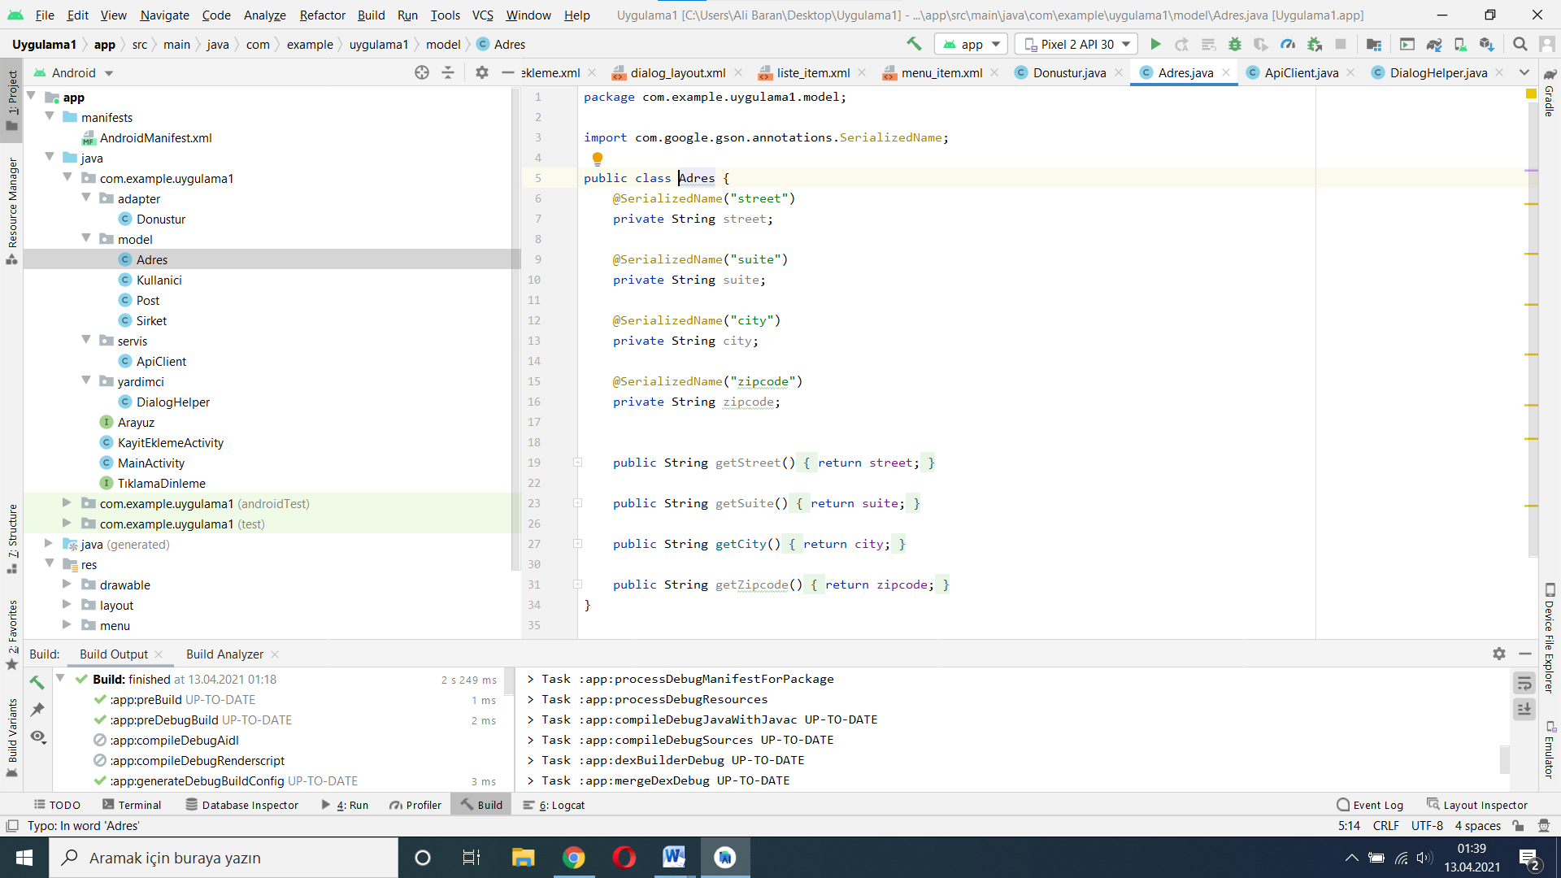

**Şekil 8.Adres.java**

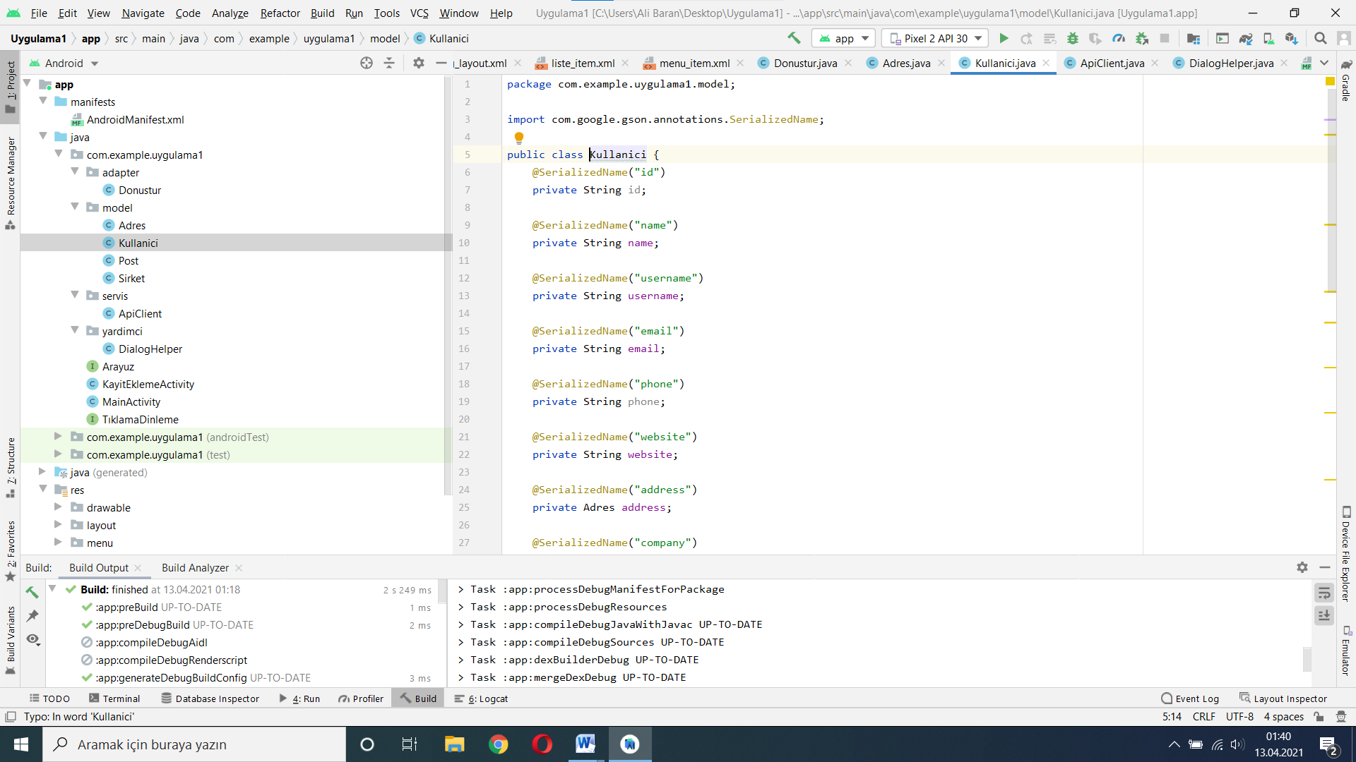

**Şekil 9.Kullanici.java**

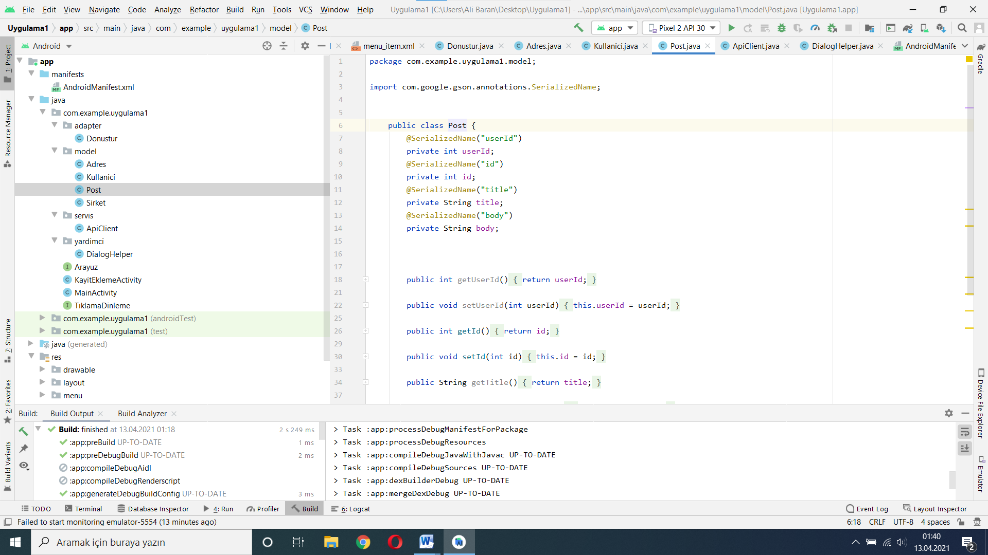

**Şekil 10.Post.java**

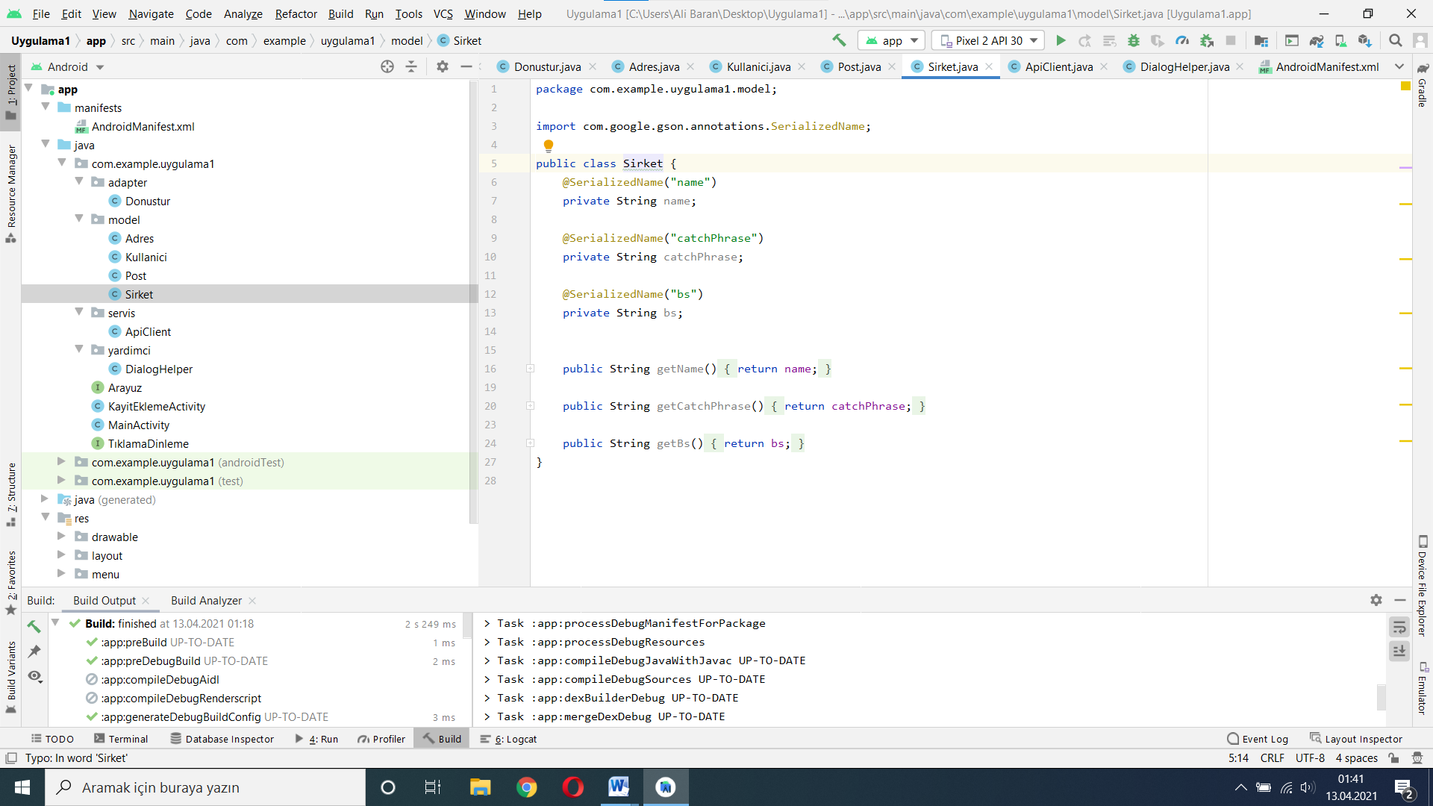

**Şekil 11.Sirket.java**

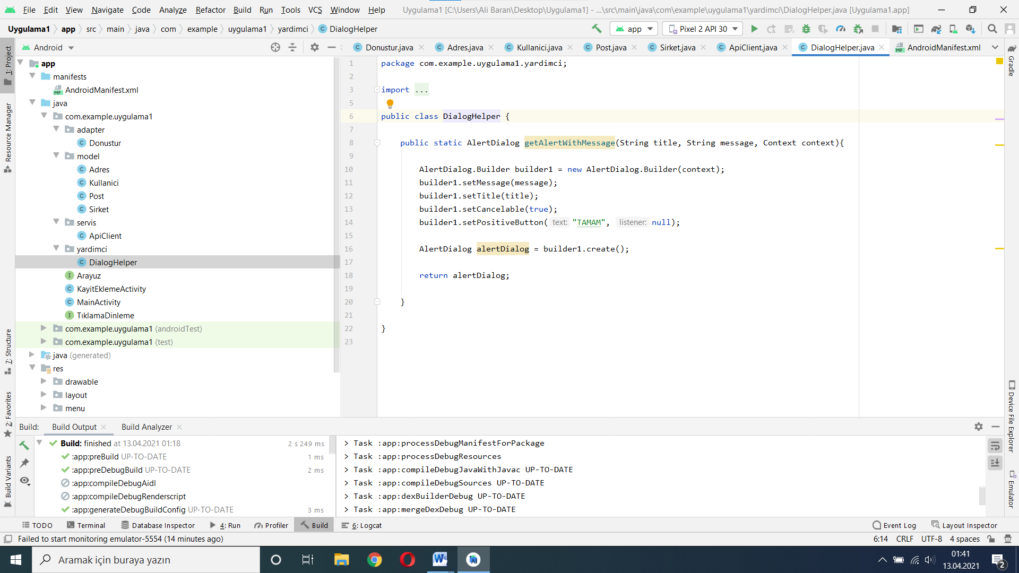

**Şekil 12.DialogHelper.java**

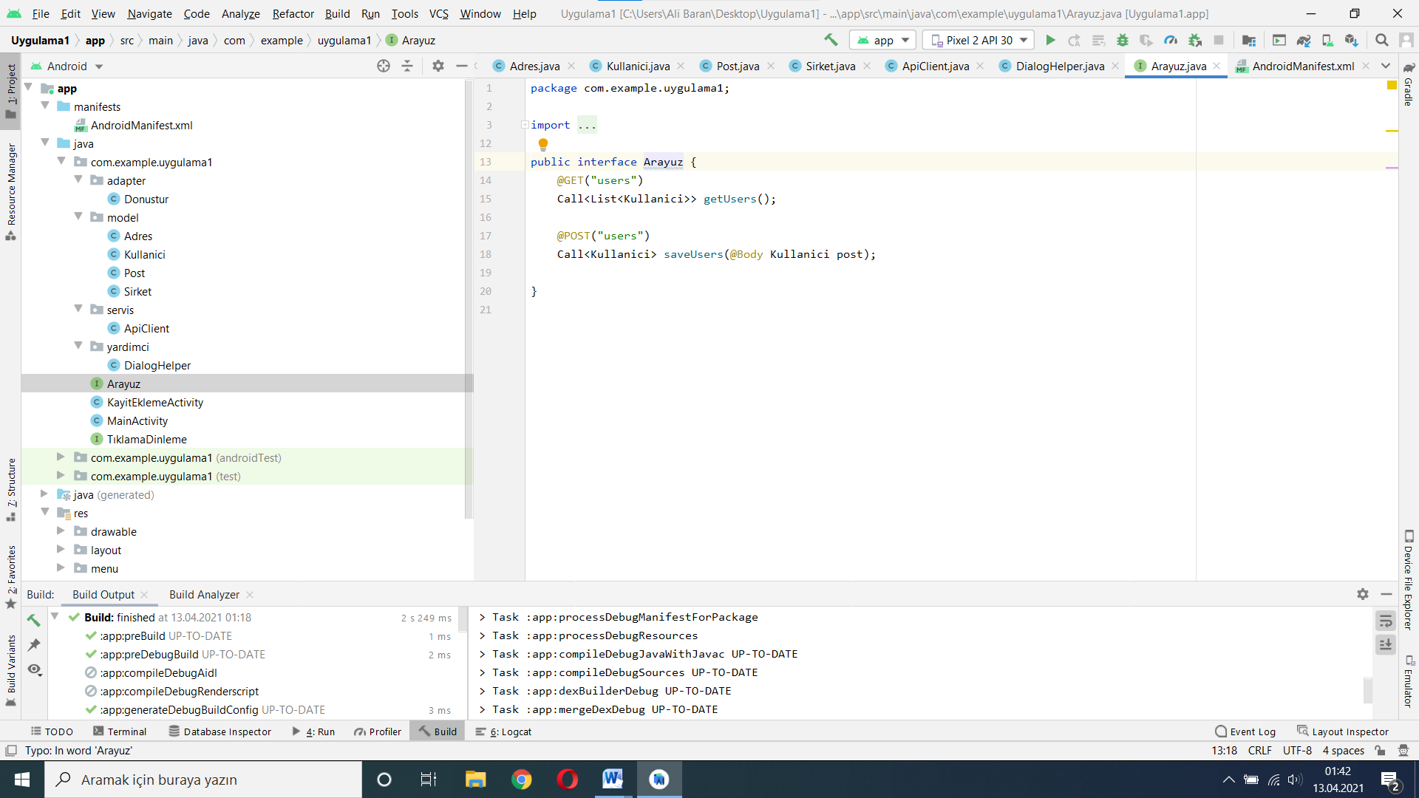

**Şekil 13.Arayuz.java**

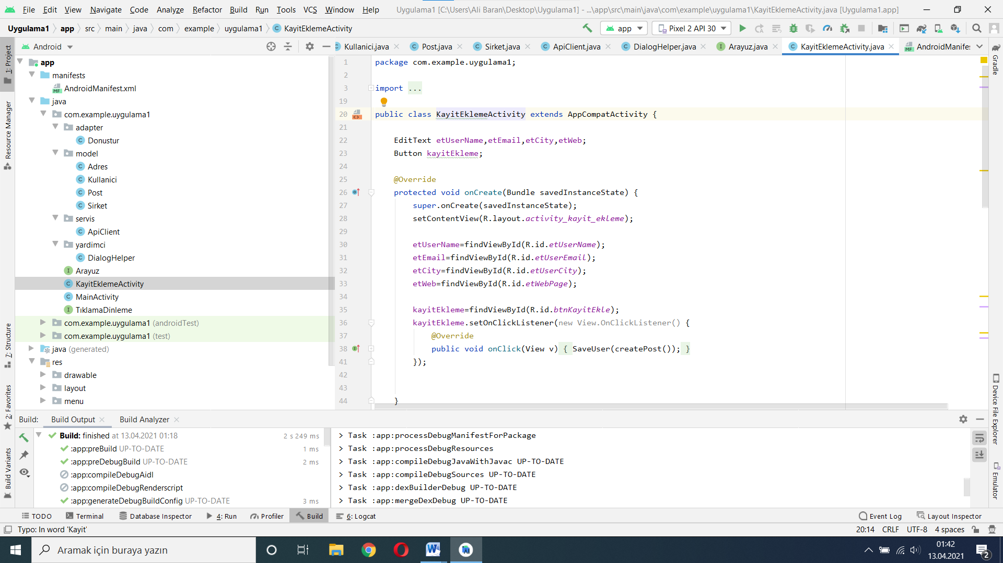

**Şekil 14.KayitEklemeActivity.java**

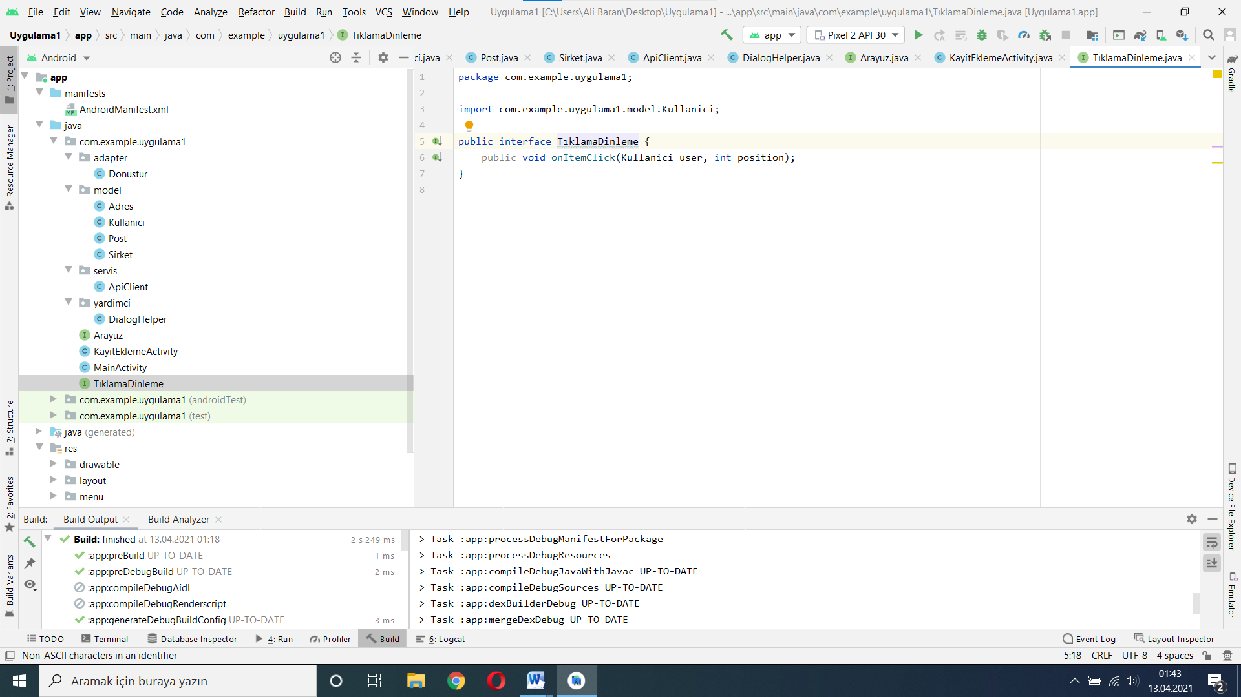

**Şekil 14.TıklamaDinleme.java**

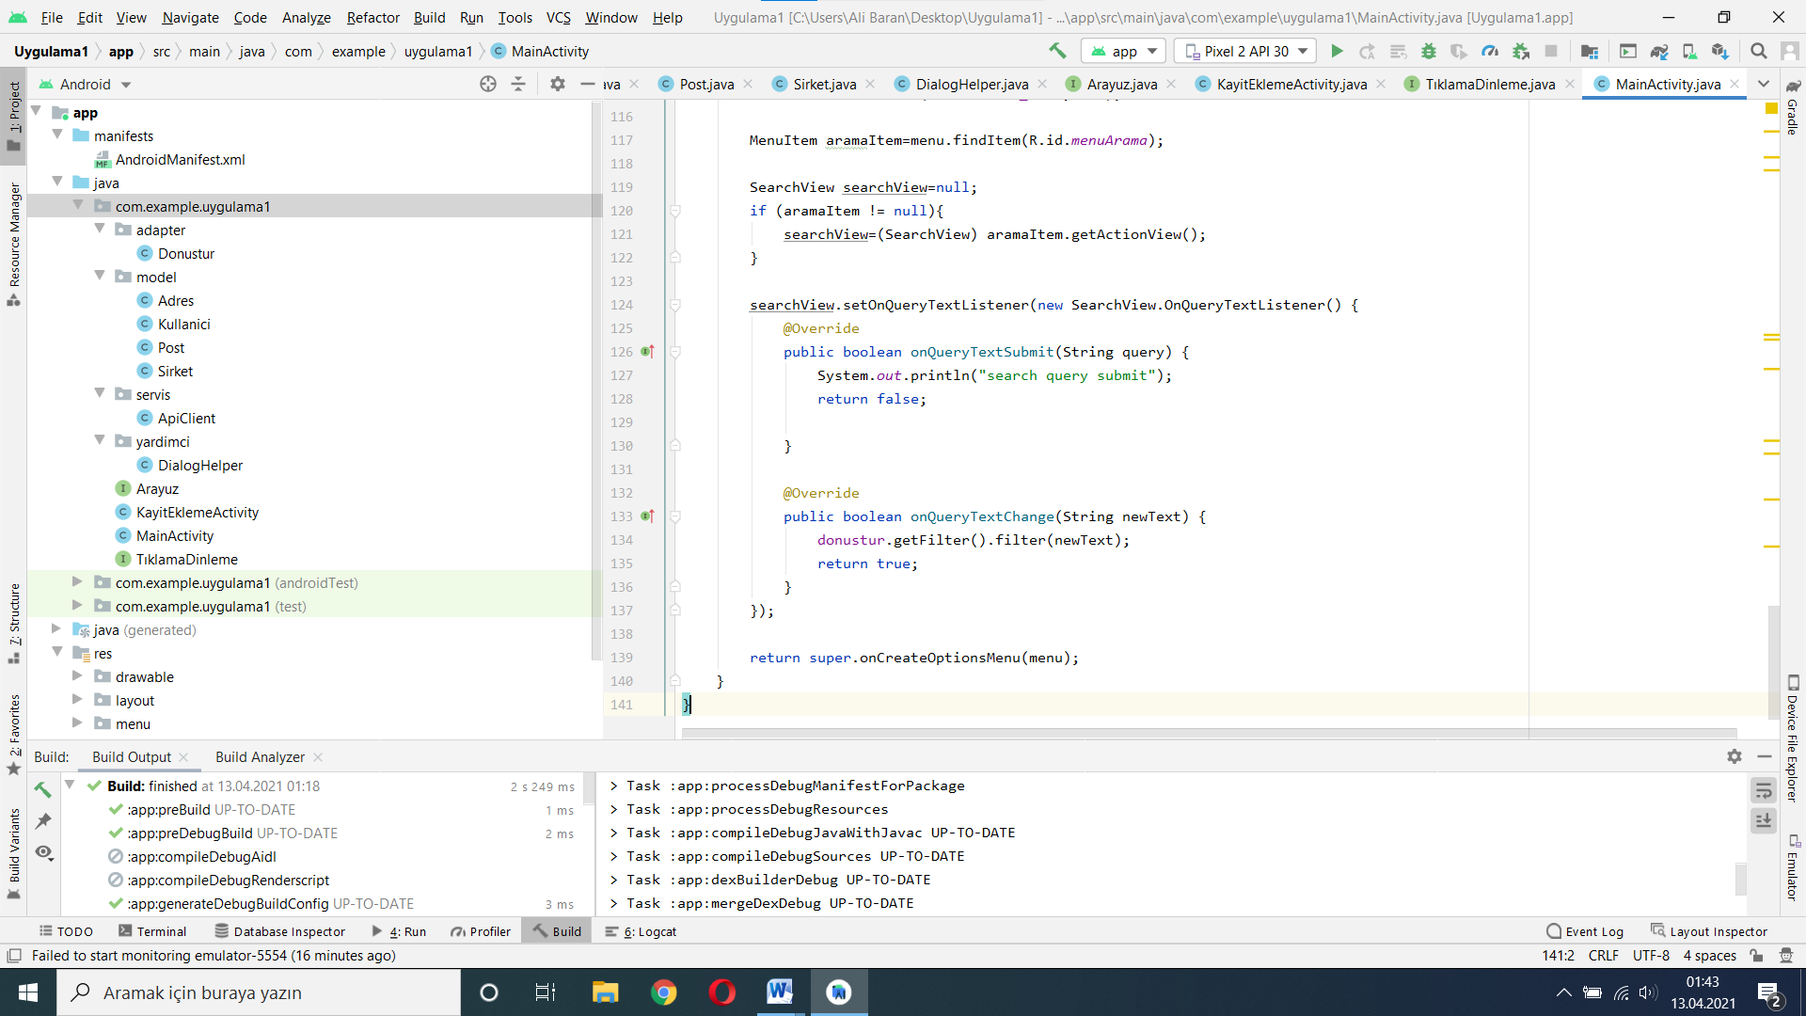

**Şekil 15.MainActivity.java**

## Activity.main.xml

*<?*xml version="1.0" encoding="utf-8"*?>*<RelativeLayout  
 xmlns:android="http://schemas.android.com/apk/res/android"  
 xmlns:app="http://schemas.android.com/apk/res-auto"  
 xmlns:tools="http://schemas.android.com/tools"  
 android:layout_width="match_parent"  
 android:layout_height="match_parent"  
 android:background="#2e2e2e"  
 tools:context=".MainActivity">  
  
 <androidx.recyclerview.widget.RecyclerView  
 android:id="@+id/recyclerView"  
 android:layout_width="match_parent"  
 android:layout_height="wrap_content"  
 android:clipToPadding="false"  
 android:scrollbars="vertical">  
  
 </androidx.recyclerview.widget.RecyclerView>  
  
 <androidx.constraintlayout.widget.ConstraintLayout  
 android:layout_width="match_parent"  
 android:layout_height="match_parent">  
  
  
  
 <com.google.android.material.floatingactionbutton.FloatingActionButton  
 android:id="@+id/faBtnEkle"  
 android:layout_width="wrap_content"  
 android:layout_height="wrap_content"  
 android:layout_marginBottom="50dp"  
 android:layout_marginRight="50dp"  
 android:backgroundTint="@android:color/darker_gray"  
 android:clickable="true"  
 android:focusable="true"  
 app:layout_constraintBottom_toBottomOf="parent"  
 app:layout_constraintEnd_toEndOf="parent"  
 app:srcCompat="@drawable/ic_add">  
  
 </com.google.android.material.floatingactionbutton.FloatingActionButton>  
  
 </androidx.constraintlayout.widget.ConstraintLayout>  
  
  
  
</RelativeLayout>

## Mainactivity.java

package com.example.uygulama1;  
  
import androidx.appcompat.app.AppCompatActivity;  
import androidx.appcompat.widget.DialogTitle;  
import androidx.appcompat.widget.SearchView;  
import androidx.recyclerview.widget.DefaultItemAnimator;  
import androidx.recyclerview.widget.GridLayoutManager;  
import androidx.recyclerview.widget.RecyclerView;  
  
import android.app.Dialog;  
import android.app.ProgressDialog;  
import android.content.Context;  
import android.content.DialogInterface;  
import android.content.Intent;  
import android.graphics.Color;  
import android.graphics.drawable.ColorDrawable;  
import android.os.Bundle;  
import android.view.Menu;  
import android.view.MenuInflater;  
import android.view.MenuItem;  
import android.view.View;  
import android.view.WindowManager;  
import android.widget.Toast;  
  
import com.example.uygulama1.adapter.Donustur;  
import com.example.uygulama1.model.Kullanici;  
import com.example.uygulama1.servis.ApiClient;  
import com.example.uygulama1.yardimci.DialogHelper;  
import com.google.android.material.floatingactionbutton.FloatingActionButton;  
  
import java.util.ArrayList;  
import java.util.List;  
  
import retrofit2.Call;  
import retrofit2.Callback;  
import retrofit2.Response;  
  
public class MainActivity extends AppCompatActivity {  
  
 FloatingActionButton faButton;  
 private RecyclerView recyclerView;  
 private Donustur donustur;  
 private ArrayList<Kullanici> kullaniciArrayList;  
 private ProgressDialog progressDialog;  
  
 @Override  
 protected void onCreate(Bundle savedInstanceState) {  
 super.onCreate(savedInstanceState);  
 setContentView(R.layout.*activity_main*);  
  
 recyclerView=(RecyclerView)findViewById(R.id.*recyclerView*);  
 GridLayoutManager glm=new GridLayoutManager(getApplicationContext(),2);  
 RecyclerView.LayoutManager layoutManager=glm;  
 recyclerView.setLayoutManager(layoutManager);  
 recyclerView.setItemAnimator(new DefaultItemAnimator());  
 faButton=findViewById(R.id.*faBtnEkle*);  
  
 getKullaniciListeFromApi();  
  
 faButton.setOnClickListener(new View.OnClickListener() {  
 @Override  
 public void onClick(View v) {  
 Intent intent=new Intent(MainActivity.this,KayitEklemeActivity.class);  
 MainActivity.this.startActivity(intent);  
   
 }  
 });  
  
 }  
  
 private void getKullaniciListeFromApi(){  
 progressDialog = createProgressDialog(MainActivity.this);  
 Arayuz arayuz= ApiClient.*getClient*().create(Arayuz.class);  
 Call<List<Kullanici>> call=arayuz.getUsers();  
 call.enqueue(new Callback<List<Kullanici>>() {  
 @Override  
 public void onResponse(Call<List<Kullanici>> call, Response<List<Kullanici>> response) {  
 progressDialog.dismiss();  
 kullaniciArrayList=new ArrayList<>(response.body());  
 donustur=new Donustur(getApplicationContext(), kullaniciArrayList, new TıklamaDinleme() {  
 @Override  
 public void onItemClick(Kullanici user, int position) {  
 Toast.*makeText*(getApplicationContext(), ""+user.getUsername(), Toast.*LENGTH_SHORT*).show();  
  
 }  
 });  
 recyclerView.setAdapter(donustur);  
 }  
  
 @Override  
 public void onFailure(Call<List<Kullanici>> call, Throwable t) {  
 progressDialog.dismiss();  
 DialogHelper.*getAlertWithMessage*("Hata",t.getMessage(),MainActivity.this);  
 }  
 });  
 }  
  
 public ProgressDialog createProgressDialog(Context mContext){  
 ProgressDialog progressDialog=new ProgressDialog(mContext);  
 try {  
 progressDialog.show();  
 }catch (WindowManager.BadTokenException e){  
  
 }  
 progressDialog.setCancelable(false);  
 progressDialog.getWindow().setBackgroundDrawable(new ColorDrawable(Color.*TRANSPARENT*));  
 progressDialog.setContentView(R.layout.*dialog_layout*);  
 return progressDialog;  
 }  
  
  
 @Override  
 public boolean onCreateOptionsMenu(Menu menu) {  
 MenuInflater menuInflater=getMenuInflater();  
 menuInflater.inflate(R.menu.*menu_item*,menu);  
  
 MenuItem aramaItem=menu.findItem(R.id.*menuArama*);  
  
 SearchView searchView=null;  
 if (aramaItem != null){  
 searchView=(SearchView) aramaItem.getActionView();  
 }  
  
 searchView.setOnQueryTextListener(new SearchView.OnQueryTextListener() {  
 @Override  
 public boolean onQueryTextSubmit(String query) {  
 System.*out*.println("search query submit");  
 return false;  
  
 }  
  
 @Override  
 public boolean onQueryTextChange(String newText) {  
 donustur.getFilter().filter(newText);  
 return true;  
 }  
 });  
  
 return super.onCreateOptionsMenu(menu);  
 }  
}

## activity_kayit_ekle.xml

*<?*xml version="1.0" encoding="utf-8"*?>*<LinearLayout xmlns:android="http://schemas.android.com/apk/res/android"  
 xmlns:app="http://schemas.android.com/apk/res-auto"  
 xmlns:tools="http://schemas.android.com/tools"  
 android:id="@+id/llEkle"  
 android:orientation="vertical"  
 android:layout_width="match_parent"  
 android:layout_height="match_parent"  
 android:background="#d5d5d5"  
 tools:context=".KayitEklemeActivity">  
  
  
 <EditText  
 android:id="@+id/etUserName"  
 android:layout_width="match_parent"  
 android:layout_height="wrap_content"  
 android:layout_marginBottom="20dp"  
 android:layout_marginTop="20dp"  
 android:layout_marginStart="50dp"  
 android:layout_marginEnd="50dp"  
 android:inputType="textPersonName"  
 android:background="@drawable/border"  
 android:hint="@string/userName"  
 android:textColorHint="#000">  
  
 </EditText>  
 <EditText  
 android:id="@+id/etUserEmail"  
 android:layout_width="match_parent"  
 android:layout_height="wrap_content"  
 android:layout_marginStart="50dp"  
 android:layout_marginEnd="50dp"  
 android:layout_marginBottom="20dp"  
 android:inputType="textPersonName"  
 android:hint="@string/userEmail"  
 android:background="@drawable/border"  
 android:textColorHint="#000">  
  
 </EditText>  
 <EditText  
 android:id="@+id/etUserCity"  
 android:layout_width="match_parent"  
 android:layout_height="wrap_content"  
 android:layout_marginStart="50dp"  
 android:layout_marginEnd="50dp"  
 android:layout_marginBottom="20dp"  
 android:inputType="textPersonName"  
 android:background="@drawable/border"  
 android:hint="@string/userCity"  
 android:textColorHint="#000">  
  
 </EditText>  
 <EditText  
 android:id="@+id/etWebPage"  
 android:layout_width="match_parent"  
 android:layout_height="wrap_content"  
 android:layout_marginStart="50dp"  
 android:layout_marginBottom="20dp"  
 android:layout_marginEnd="50dp"  
 android:inputType="textPersonName"  
 android:hint="@string/userWebPage"  
 android:background="@drawable/border"  
 android:textColorHint="#000">  
  
 </EditText>  
  
 <Button  
 android:id="@+id/btnKayitEkle"  
 android:layout_width="match_parent"  
 android:layout_height="wrap_content"  
 android:layout_marginTop="25dp"  
 android:layout_marginStart="100dp"  
 android:layout_marginEnd="100dp"  
 android:textStyle="bold"  
 android:textSize="17sp"  
 android:textColor="#fff"  
 android:background="@drawable/border"  
 android:backgroundTint="#2e2e2e"  
 android:text="@string/tvKayitEkleme"  
 >  
  
 </Button>  
  
  
  
  
</LinearLayout>

## Dialog_layout.xml

*<?*xml version="1.0" encoding="utf-8"*?>*<RelativeLayout xmlns:android="http://schemas.android.com/apk/res/android"  
 android:layout_width="match_parent"  
 android:layout_height="match_parent"  
 android:layout_gravity="center"  
 android:background="@android:color/transparent">  
  
 <ProgressBar  
 android:id="@+id/progresBar"  
 android:layout_width="wrap_content"  
 android:layout_height="wrap_content"  
 android:layout_centerInParent="true">  
  
 </ProgressBar>  
  
</RelativeLayout>

## Liste_item.xml

*<?*xml version="1.0" encoding="utf-8"*?>*<LinearLayout xmlns:android="http://schemas.android.com/apk/res/android"  
 xmlns:app="http://schemas.android.com/apk/res-auto"  
 android:orientation="vertical"  
 android:layout_width="match_parent"  
 android:layout_height="wrap_content">  
  
 <androidx.cardview.widget.CardView  
 android:layout_width="match_parent"  
 android:layout_height="match_parent"  
 android:layout_gravity="center"  
 android:layout_margin="15dp"  
 android:elevation="3dp"  
 app:cardCornerRadius="9dp">  
  
 <RelativeLayout  
 android:layout_width="match_parent"  
 android:layout_height="match_parent">  
  
 <ImageView  
 android:id="@+id/userResim"  
 android:layout_width="wrap_content"  
 android:layout_height="50dp"  
 android:layout_margin="5dp"  
 android:scaleType="fitCenter"  
 app:srcCompat="@drawable/ic_person"  
 android:layout_centerHorizontal="true"  
 android:background="?attr/selectableItemBackgroundBorderless">  
   
 </ImageView>  
   
 <LinearLayout  
 android:layout_width="match_parent"  
 android:layout_height="wrap_content"  
 android:layout_below="@id/userResim"  
 android:layout_margin="10dp"  
 android:orientation="vertical">  
  
 <LinearLayout  
 android:orientation="vertical"  
 android:layout_width="match_parent"  
 android:layout_height="wrap_content">  
  
 <LinearLayout  
 android:layout_width="match_parent"  
 android:layout_height="wrap_content"  
 android:orientation="horizontal"  
 android:layout_marginBottom="10dp"  
 android:gravity="center_vertical"  
 android:weightSum="1">  
  
 <TextView  
 android:layout_width="0dp"  
 android:layout_height="wrap_content"  
 android:textSize="12sp"  
 android:textStyle="bold"  
 android:layout_weight="0.4"  
 android:text="@string/userName" />  
  
 <TextView  
 android:layout_width="0dp"  
 android:layout_height="wrap_content"  
 android:textStyle="italic"  
 android:textSize="12sp"  
 android:id="@+id/userName"  
 android:layout_weight="0.6"  
 android:text="" />  
  
 </LinearLayout>  
  
 <LinearLayout  
 android:layout_width="match_parent"  
 android:layout_height="wrap_content"  
 android:layout_marginBottom="10dp"  
 android:weightSum="1"  
 android:gravity="center_vertical"  
 android:orientation="horizontal">  
  
 <TextView  
 android:textSize="12sp"  
 android:textStyle="bold"  
 android:layout_width="0dp"  
 android:layout_height="wrap_content"  
 android:layout_weight="0.4"  
 android:text="@string/userEmail" />  
  
 <TextView  
 android:id="@+id/userEmail"  
 android:textStyle="italic"  
 android:textSize="12sp"  
 android:text=""  
 android:layout_width="0dp"  
 android:layout_height="wrap_content"  
 android:layout_weight="0.6" />  
 </LinearLayout>  
  
  
 </LinearLayout>  
  
 <LinearLayout  
 android:layout_width="match_parent"  
 android:layout_height="wrap_content"  
 android:orientation="vertical">  
  
 </LinearLayout>  
  
  
 <LinearLayout  
 android:layout_width="match_parent"  
 android:layout_height="wrap_content"  
 android:orientation="vertical"  
 >  
  
  
 <LinearLayout  
 android:layout_width="match_parent"  
 android:layout_height="wrap_content"  
 android:layout_marginBottom="10dp"  
 android:weightSum="1"  
 android:gravity="center_vertical"  
 android:orientation="horizontal">  
  
 <TextView  
 android:textSize="12sp"  
 android:textStyle="bold"  
 android:layout_width="0dp"  
 android:layout_height="wrap_content"  
 android:layout_weight="0.4"  
 android:text="@string/userCity" />  
  
 <TextView  
 android:layout_height="wrap_content"  
 android:layout_weight="0.6"  
 android:id="@+id/userCity"  
 android:textStyle="italic"  
 android:textSize="12sp"  
 android:layout_width="0dp"  
 android:text="" />  
  
 </LinearLayout>  
  
 <LinearLayout  
 android:layout_width="match_parent"  
 android:layout_height="wrap_content"  
 android:weightSum="1"  
 android:gravity="center_vertical"  
 android:orientation="horizontal">  
  
 <TextView  
 android:textSize="12sp"  
 android:textStyle="bold"  
 android:layout_width="0dp"  
 android:layout_height="wrap_content"  
 android:layout_weight="0.4"  
 android:text="@string/userWebPage" />  
  
 <TextView  
 android:layout_width="0dp"  
 android:layout_height="wrap_content"  
 android:textStyle="italic"  
 android:textSize="12sp"  
 android:id="@+id/userWebPage"  
 android:text=""  
 android:layout_weight="0.6" />  
 </LinearLayout>  
  
  
 </LinearLayout>  
  
  
  
 </LinearLayout>  
 </RelativeLayout>  
  
  
  
  
  
  
 </androidx.cardview.widget.CardView>  
  
</LinearLayout>

## Menü_item.xml

*<?*xml version="1.0" encoding="utf-8"*?>*<menu xmlns:android="http://schemas.android.com/apk/res/android"  
 xmlns:app="http://schemas.android.com/apk/res-auto">  
  
 <item  
 android:id="@+id/menuArama"  
 android:title="Arama"  
 app:actionViewClass="androidx.appcompat.widget.SearchView"  
 app:showAsAction="always">  
  
 </item>  
  
  
  
</menu>

## Donustur.java

package com.example.uygulama1.adapter;  
  
import android.content.Context;  
import android.view.LayoutInflater;  
import android.view.View;  
import android.view.ViewGroup;  
import android.widget.Filter;  
import android.widget.Filterable;  
import android.widget.TextView;  
  
import androidx.annotation.NonNull;  
import androidx.recyclerview.widget.RecyclerView;  
  
import com.example.uygulama1.R;  
import com.example.uygulama1.TıklamaDinleme;  
import com.example.uygulama1.model.Kullanici;  
  
import java.util.ArrayList;  
  
public class Donustur extends RecyclerView.Adapter<Donustur.mViewHolder> implements Filterable {  
  
 private TıklamaDinleme tıklamaDinleme;  
 private Context context;  
 private ArrayList<Kullanici> kullaniciListe;  
 private ArrayList<Kullanici> filteredKullaniciListe;  
  
 public Donustur(Context context,ArrayList<Kullanici> kullaniciArrayList,TıklamaDinleme dinleme) {  
 this.context=context;  
 this.kullaniciListe=kullaniciArrayList;  
 this.filteredKullaniciListe=kullaniciArrayList;  
 this.tıklamaDinleme=dinleme;  
 }  
  
  
  
 @NonNull  
 @Override  
 public Donustur.mViewHolder onCreateViewHolder(@NonNull ViewGroup parent, int viewType) {  
 View view=LayoutInflater.*from*(parent.getContext()).inflate(R.layout.*liste_item*,parent,false);  
 final mViewHolder viewHolder=new mViewHolder(view);  
 view.setOnClickListener(new View.OnClickListener() {  
 @Override  
 public void onClick(View v) {  
 *//* tıklamaDinleme.onItemClick(filteredKullaniciListe.get(viewHolder.getAdapterPosition()),viewHolder.getAdapterPosition());  
 }  
 });  
 return viewHolder;  
 }  
  
 @Override  
 public void onBindViewHolder(@NonNull Donustur.mViewHolder holder, int position) {  
 holder.userName.setText(filteredKullaniciListe.get(position).getUsername());  
 holder.userCity.setText(filteredKullaniciListe.get(position).getAddress().getCity());  
 holder.userWeb.setText(filteredKullaniciListe.get(position).getWebsite());  
 holder.userEmail.setText(filteredKullaniciListe.get(position).getEmail());  
  
 }  
  
 @Override  
 public int getItemCount() {  
 return filteredKullaniciListe.size();  
 }  
  
 @Override  
 public Filter getFilter() {  
 return new Filter() {  
 @Override  
 protected FilterResults performFiltering(CharSequence constraint) {  
 String arananKelime=constraint.toString();  
 if (arananKelime.isEmpty()){  
 filteredKullaniciListe=kullaniciListe;  
 }else{  
 ArrayList<Kullanici> geciciFilteredListe=new ArrayList<>();  
 for (Kullanici kullanici:kullaniciListe){  
 if (kullanici.getUsername().toLowerCase().contains(arananKelime)){  
 geciciFilteredListe.add(kullanici);  
 }  
 }  
 filteredKullaniciListe=geciciFilteredListe;  
 }  
 Filter.FilterResults filterResults=new Filter.FilterResults();  
 filterResults.values=filteredKullaniciListe;  
 return filterResults;  
 }  
  
 @Override  
 protected void publishResults(CharSequence constraint, FilterResults results) {  
 filteredKullaniciListe=(ArrayList<Kullanici>) results.values;  
 notifyDataSetChanged();  
 }  
 };  
 }  
  
 public class mViewHolder extends RecyclerView.ViewHolder {  
 private TextView userName;  
 private TextView userEmail;  
 private TextView userCity;  
 private TextView userWeb;  
  
  
  
  
 public mViewHolder(@NonNull View itemView) {  
 super(itemView);  
 userName = (TextView)itemView.findViewById(R.id.*userName*);  
 userEmail = (TextView)itemView.findViewById(R.id.*userEmail*);  
 userWeb = (TextView)itemView.findViewById(R.id.*userWebPage*);  
 userCity = (TextView)itemView.findViewById(R.id.*userCity*);  
 }  
 }  
  
  
}

## ApiClient.java

package com.example.uygulama1.servis;  
  
import com.example.uygulama1.Arayuz;  
  
import retrofit2.Retrofit;  
import retrofit2.converter.gson.GsonConverterFactory;  
  
public class ApiClient {  
 public static final String *BASE_URL* = "https://jsonplaceholder.typicode.com/";  
 private static Retrofit *retrofit*=null;  
 public static Retrofit getClient(){  
 if (*retrofit*==null){  
 *retrofit*=new Retrofit.Builder()  
 .baseUrl(*BASE_URL*)  
 .addConverterFactory(GsonConverterFactory.*create*())  
 .build();  
 }  
 return *retrofit*;  
 }  
  
 public static Arayuz getUserService(){  
 Arayuz arayuzServis=*getClient*().create(Arayuz.class);  
 return arayuzServis;  
  
 }  
  
  
}

## DialogHelper.java

package com.example.uygulama1.yardimci;  
  
import android.app.AlertDialog;  
import android.content.Context;  
  
public class DialogHelper {  
  
 public static AlertDialog getAlertWithMessage(String title, String message, Context context){  
  
 AlertDialog.Builder builder1 = new AlertDialog.Builder(context);  
 builder1.setMessage(message);  
 builder1.setTitle(title);  
 builder1.setCancelable(true);  
 builder1.setPositiveButton("TAMAM", null);  
  
 AlertDialog alertDialog = builder1.create();  
  
 return alertDialog;  
  
 }  
  
}